**Raid**

RAID 0: Is implemented by striping blocks. Excellent performance, no redundancy. Using RAID 0 we can use the eight fast disks and disregard the two slow disks. Meaning the speed will be 8000MBs/S

**B-Trees**

Binary Tree B-Tree

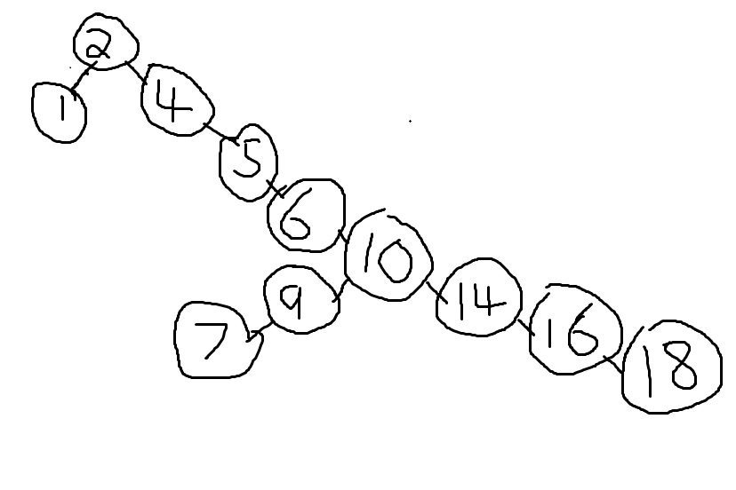 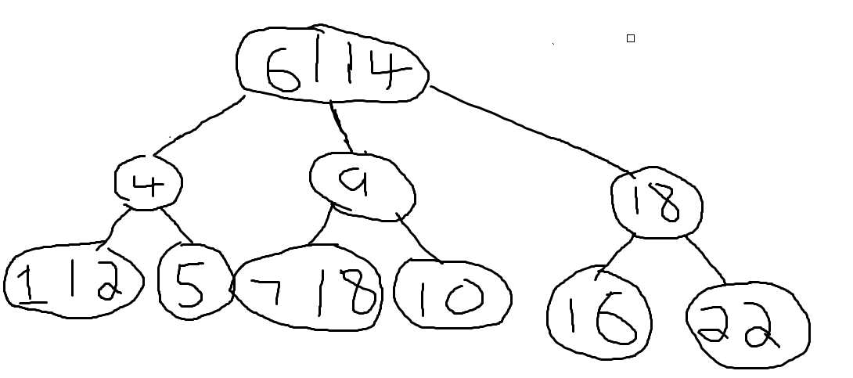

This particular binary tree is skewed right (i.e. the vast majority of the nodes are to the right of the first node). Where as with the B-tree there is a move even distribution of nodes.   
  
The main advantage of using a B-tree is that searching is much more efficient in B-trees than in binary trees.

**Contraints and Triggers**

A. Create Or Replace Trigger logTrig  
 After Insert on Teams  
 Begin  
 Insert into logTable values(“insert done”, SYSDATE);  
 END;

B. Check(Competition=”Champions League” Or Competition=”Europa League” or Competition=”Premier League” or Competition=”La Liga”);

C. Check(TeamA_ID.country= “England” Or TeamA_ID=”Spain”);  
 Check(TeamB_ID.country =”England” Or TeamB_ID=”Spain”);

D. Check(Goal_A >=0 <= Goal_B);

E. Create Or Replace Trigger LeagueComp  
 Before Insert Or Update On Matches  
 Begin  
 If Competition = “Premier League”  
 Where TeamA_ID = Team_ID   
 Check(TeamA_ID=”England”);  
 And Where TeamB_ID=Team_ID  
 Check(TeamB_ID=”England”);

Else If Competition = “La Liga”  
 Where TeamA_ID = Team_ID   
 Check(TeamA_ID=”Spain”);  
 And Where TeamB_ID=Team_ID  
 Check(TeamB_ID=”Spain”);  
 END;

F. CREATE OR REPLACE TRIGGER home_trg

BEFORE INSERT OR UPDATE ON matches

FOR EACH ROW

DECLARE

how_many NUMBER;

BEGIN

SELECT COUNT(*) INTO how_many FROM matches

WHERE TeamA_ID = :new.TeamA_ID;

IF how_many >= 3 then

Raise_application_error(-20000,'HomeTeam' ||

:new.TeamA_ID || 'already has 3 Home Games');

END IF;

END;